

Parallel & Distributed Computing

CSE525

Assignment **#7** - to be submitted to **Dr. Masroor Hussain**

**Comparison of GPU’s vs. CPU’s performance with OpenCL based Matrix Multiplication Code**

Submitted by,

**Quswar Mahmood Abid, CS2003**

OpenCL - Matrix Multiplication

Install OpenCL and compare its results on CPU and GPU, submit a report

In this assignment, we are required to setup OpenCL on our system and run Matrix Multiplication code on CPU and GPU to compare the two of them. Remember that the performance may vary significantly from system to system and different hardware specs. Therefore, it is important to notice the details of hardware we are using. Following snapshot shows the DXDIAG results on my Core i3, Windows laptop PC.

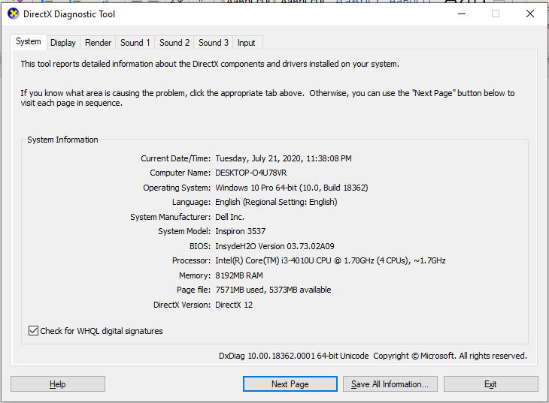

Figure . processor specs

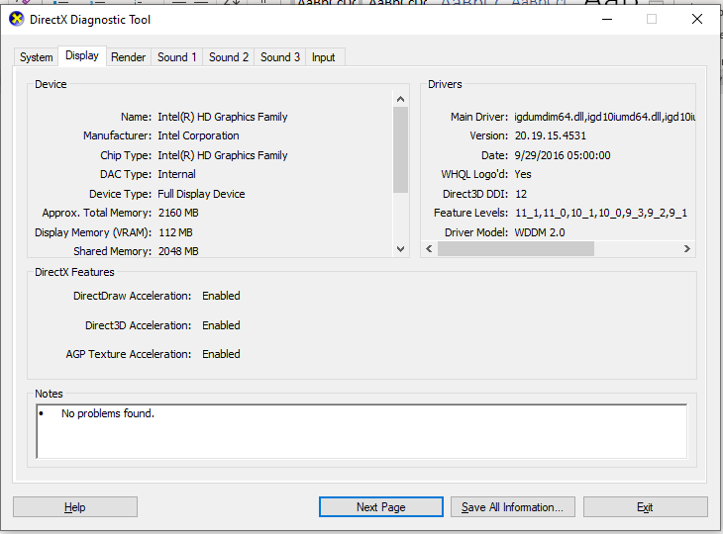

Figure . graphics card specs

The code I have chosen is sourced from a freely published [gist on GitHub by Tanay Prabhu Desai](https://gist.github.com/tanayseven/726c50a1dc419ea57e64). A fork of it is available on [my GitHub](https://gist.github.com/quswarabid/1df2269149970ce77f12727748390375). This code contains a matrix multiplication code for a pre-filled matrix of size 3x3. Navigate to the folder containing codes, and compile with this command in CMD:

**gcc -I. mat_mul.c C:\Windows\System32\OpenCL.dll -o main.exe**

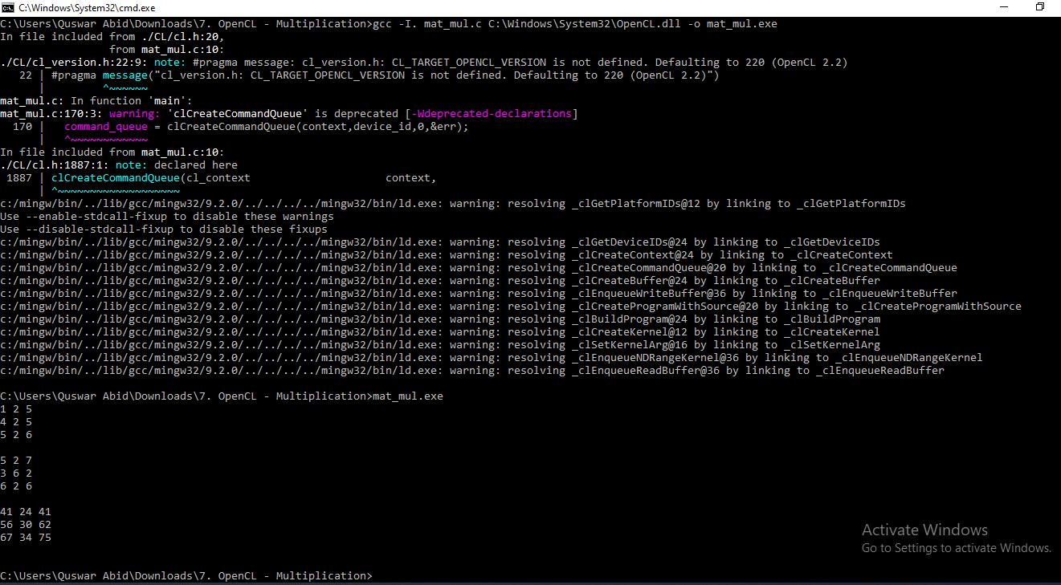

Figure . compiling it with OpenCL dynamic linking library from system

Note the time using PowerShell with this:

**Measure-Command {start-process mat_mul.exe -wait}**

To run on CPU, go to line 157, change **CL_DEVICE_TYPE_\*\*\*** to **CL_DEVICE_TYPE_CPU**, recompile and re-run. Now change the device type to GPU and recompile.

To run on GPU, go to line 157, change **CL_DEVICE_TYPE_\*\*\*** to **CL_DEVICE_TYPE_GPU**, recompile and re-run. Notice the time taken by two in following figure.

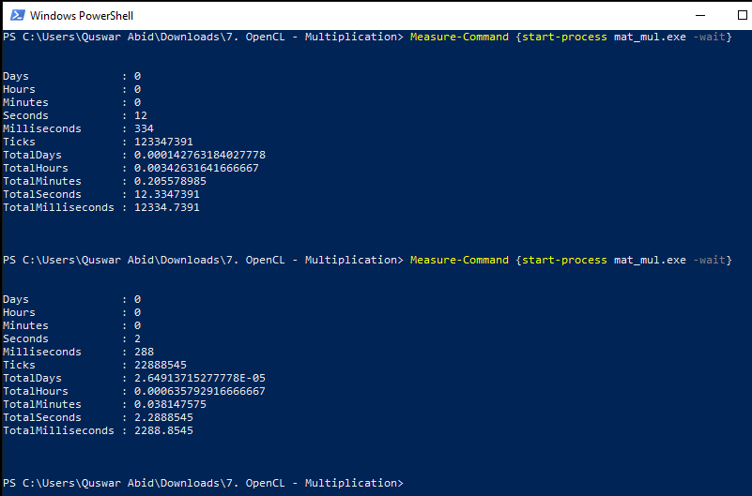

Figure . time taken by CPU vs. GPU based OpenCL

As you can see that there is a clear difference between the running time of two. Running time of CPU is 4x as compared to GPU.

* Time taken by CPU is **12334.7391 ms**
* Time taken by GPU is **2288.8545 ms**

Code files are attached with this report.